**PIZZA SALES SQL QUERIES**

1. **KPI’s**
2. Total Revenue:

SELECT SUM (total_price) AS Total_Revenue

FROM pizza_sales;

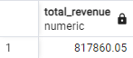

1. Average Order Value:

SELECT SUM (total_price) / COUNT (DISTINCT order_id) AS Average_Order_Value

FROM pizza_sales;



1. Total Pizza’s Sold:

SELECT SUM (quantity) AS Total_Pizzas_Sold

FROM pizza_sales;



1. Total Orders:

SELECT COUNT (DISTINCT order_id) AS Total_Orders

FROM pizza_sales;

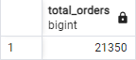

1. Average Pizza’s Per Order

SELECT CAST (CAST (SUM (quantity) AS DECIMAL (10,2)) /

CAST (COUNT (DISTINCT order_id) AS DECIMAL (10,2)) AS DECIMAL (10,2))

AS Average_Pizzas_Per_Order

FROM pizza_sales;



1. **Daily Trend for Total Order:**

SELECT to_char (order_date, 'Day') AS Order_Day, COUNT (DISTINCT order_id) AS Total_Orders

FROM pizza_sales

GROUP BY Order_Day;

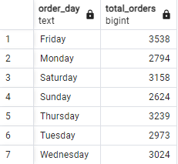

1. **Monthly Trend for Total Orders:**

SELECT to_char (order_date, 'Month') As Order_Month, COUNT (DISTINCT order_id) AS Total_Orders

FROM pizza_sales

GROUP BY Order_Month;

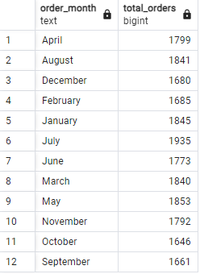

1. **% of Sales by Pizza Category:**

SELECT pizza_category, SUM (total_price) AS Total_Revenue,

CAST( SUM (total_price) * 100 / (SELECT SUM (total_price) FROM pizza_sales)AS DECIMAL (10,2)) AS PCT

FROM pizza_sales

GROUP BY pizza_category;

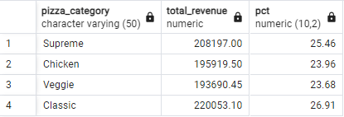

1. **% of Sales by Pizza Size:**

SELECT pizza_size,SUM (total_price) AS Total_Revenue,

CAST( SUM (total_price) * 100 / (SELECT SUM (total_price) FROM pizza_sales)AS DECIMAL (10,2)) AS PCT

FROM pizza_sales

GROUP BY pizza_size

ORDER BY pizza_size;

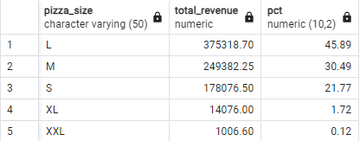

1. **Total Pizza Sold by Category:**

SELECT pizza_category, SUM(quantity) as Total_Quantity_Sold

FROM pizza_sales

GROUP BY pizza_category

ORDER BY Total_Quantity_Sold DESC

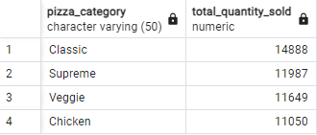

1. **Top 5 Pizzas by Revenue:**

SELECT pizza_name,SUM (total_price) AS Total_Revenue

FROM pizza_sales

GROUP BY pizza_name

ORDER BY Total_Revenue DESC

LIMIT 5

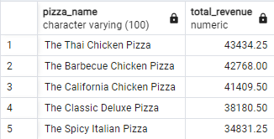

1. **Bottom 5 Pizzas by Revenue:**

SELECT pizza_name, SUM (total_price) AS Total_Revenue

FROM pizza_sales

GROUP BY pizza_name

ORDER BY Total_Revenue ASC

LIMIT 5

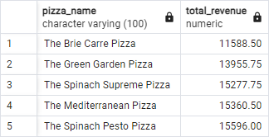

1. **Top 5 Pizzas by Quantity:**

SELECT pizza_name, SUM (quantity) AS Total_quantity

FROM pizza_sales

GROUP BY pizza_name

ORDER BY Total_quantity DESC

LIMIT 5

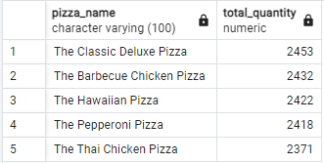

1. **Bottom 5 Pizzas by Quantity:**

SELECT pizza_name, SUM (quantity) AS Total_quantity

FROM pizza_sales

GROUP BY pizza_name

ORDER BY Total_quantity ASC

LIMIT 5

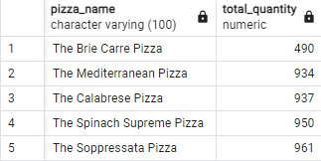

1. **Top 5 Pizzas by Total Orders:**

SELECT pizza_name, COUNT (DISTINCT order_id) AS Total_Orders

FROM pizza_sales

GROUP BY pizza_name

ORDER BY Total_Orders DESC

LIMIT 5

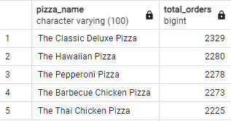

1. **Bottom 5 Pizzas by Total Orders:**

SELECT pizza_name, COUNT (DISTINCT order_id) AS Total_Orders

FROM pizza_sales

GROUP BY pizza_name

ORDER BY Total_Orders ASC

LIMIT 5

